**NALLA MALLA REDDY**

**ENGINEERING COLLEGE**

**DOCUMENT**

**ON**

**Tracking a product**

**landing page**

**Name:MANTHRI SAI KIRAN**

**Roll No:23B65A0509**

**Section:CSE-3B**

**Project Title: tracking a product landing page**

**Here’s how you can design a product landing page with HTML and CSS, and then track and commit your files using Git:**

1. **Create the HTML and CSS Files**

**First, you need to create your HTML and CSS files.**

**HTML (product_landing.html)**

<!DOCTYPE html>

<html lang=”en”>

<head>

<meta charset=”UTF-8”>

<meta name=”viewport” content=”width=device-width, initial-scale=1.0”>

<title>Product Landing Page</title>

<link rel=”stylesheet” href=”styles.css”>

</head>

<body>

<header>

<nav>

<ul>

<li><a href=”#features”>Features</a></li>

<li><a href=”#pricing”>Pricing</a></li>

<li><a href=”#contact”>Contact</a></li>

</ul>

</nav>

<h1>Our Amazing Product</h1>

<p>The best solution for your needs!</p>

<a href=”#cta” class=”cta-button”>Get Started Now</a>

</header>

<section id=”features”>

<h2>Features</h2>

<div class=”feature”>

<h3>Feature One</h3>

<p>Describe the first feature here.</p>

</div>

<div class=”feature”>

<h3>Feature Two</h3>

<p>Describe the second feature here.</p>

</div>

<div class=”feature”>

<h3>Feature Three</h3>

<p>Describe the third feature here.</p>

</div>

</section>

<section id=”pricing”>

<h2>Pricing</h2>

<p>Choose the best plan that suits your needs.</p>

<div class=”pricing-plan”>

<h3>Basic Plan</h3>

<p>$9.99/month</p>

</div>

<div class=”pricing-plan”>

<h3>Pro Plan</h3>

<p>$19.99/month</p>

</div>

<div class=”pricing-plan”>

<h3>Enterprise Plan</h3>

<p>Contact us for pricing</p>

</div>

</section>

<section id=”contact”>

<h2>Contact Us</h2>

<p>Have questions? Reach out to us!</p>

<form action=”#” method=”post”>

<input type=”text” name=”name” placeholder=”Your Name”>

<input type=”email” name=”email” placeholder=”Your Email”>

<textarea name=”message” placeholder=”Your Message”></textarea>

<button type=”submit”>Send Message</button>

</form>

</section>

<footer>

<p>&copy; 2024 Our Amazing Product. All rights reserved.</p>

</footer>

</body>

</html>

**CSS (styles.css)**

Body {

Font-family: Arial, sans-serif;

Margin: 0;

Padding: 0;

Line-height: 1.6;

}

Header {

Background-color: #333;

Color: white;

Padding: 20px;

Text-align: center;

}

Nav ul {

List-style-type: none;

Padding: 0;

}

Nav ul li {

Display: inline;

Margin: 0 10px;

}

Nav ul li a {

Color: white;

Text-decoration: none;

}

H1 {

Margin-top: 10px;

}

P {

Margin: 10px 0;

}

.cta-button {

Display: inline-block;

Padding: 10px 20px;

Background-color: #e8491d;

Color: white;

Text-decoration: none;

Border-radius: 5px;

Margin-top: 10px;

}

Section {

Padding: 20px;

Text-align: center;

}

.feature, .pricing-plan {

Margin: 20px 0;

}

Footer {

Background-color: #333;

Color: white;

Text-align: center;

Padding: 10px;

Margin-top: 20px;

}

1. **Track and Commit Files Using Git**

Once you have created the product_landing.html and styles.css files, you can use Git to track and commit these files.

**Step 1: Initialize Git Repository (if not already done)**

If you haven’t initialized a Git repository in your project folder, do so by running:

Git init

**Step 2: Track the Files**

To start tracking your HTML and CSS files, use the git add command:

Git add product_landing.html styles.css

This command stages the files, making them ready for the commit.

**Step 3: Commit the Files**

Once the files are staged, commit them with a meaningful commit message: Git commit -m “Create product landing page”

This command commits the changes with the message

“Create product landing page”, recording the state of your project at this point.

**Ouput:**

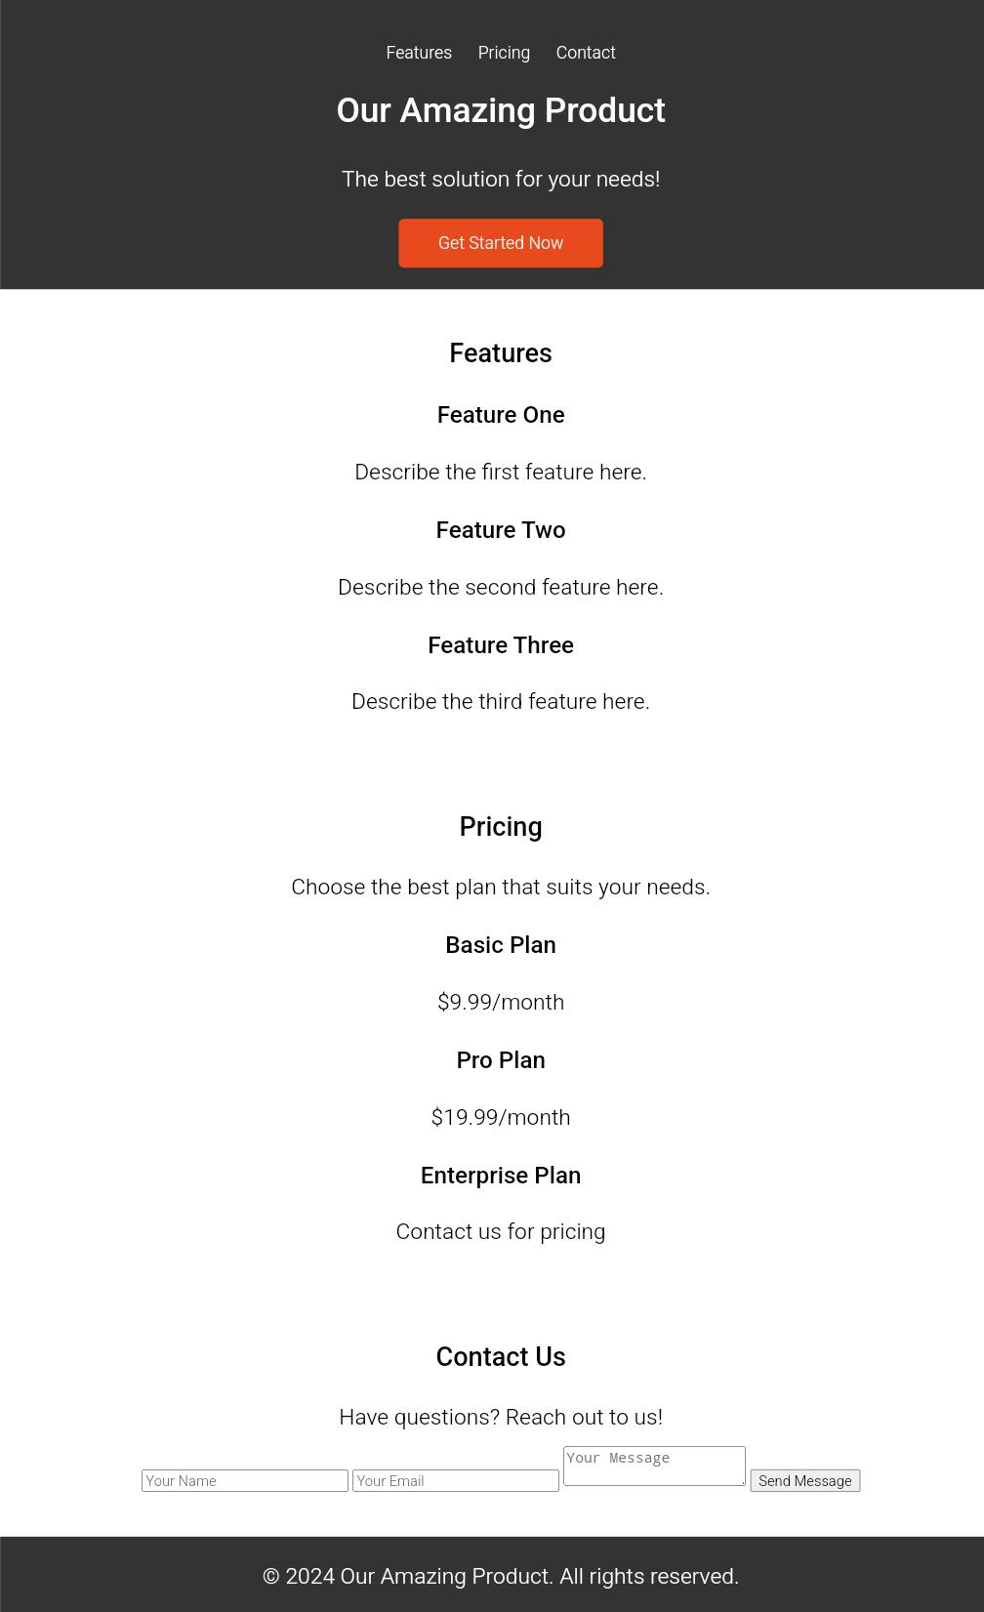

**Conclusion:**

**You’ve now successfully created a product landing page using HTML and CSS, and you’ve tracked and committed your files using Git. This is a foundational process in web development and version control, allowing you to maintain and manage changes in your project efficiently.**